APPENDIX B.2 – Functional Prototype Specification
Iterative Prototyping

Activity 2 – Functional Prototype Specification
Using your knowledge and experience of what constitutes a good basic online web store, come out with the different modules that make up new website prototype.
Document down using the form below:

(a) Project Objectives
State the objective of your new website prototype
Our objective for the new website prototype would be to make our website that sells IT gadgets which is also user friendly and secure.

- Functional requirements
List down key functional requirements your project. Categorise them by modules/page. Provide details of each functions listed. These can come from the basic features of what makes a good website AND also features from STEP 5 of activity 1.
Also write down who in your team is responsible for each of the features mentioned.
Be AS SPECIFIC AS POSSIBLE in your descriptions of the functionality for your website.
In my example here, I have included the basic parts of an online shopping site, and also features from STEP 5 in activity 1 . Please erase/modify the space below and insert our own functional requirements.
Functionality | Who is responsible?
Welcome Page  Basic Features:  - Feature 1 Login Dialog with 2 factor authentication  - Feature 2 Displays Top 3 most popular products (image + description)  - Feature 3 User greetings of login user & Last login date/time…..  - Feature 4 Display of Monthly Special ( E.g Valentine’s Day Special, Black friday sales)  -Feature 5 Input Validation  -Feature 6 Daily login rewards  -Feature 7 Last viewed item  CRUD Features:  C: Create feedback form (user)  R: View all feedback by users. (admin)  U: Allow users to edit feedback before submitting.  D: Clear all feedback. (admin)  New Member Registration page  Basic Features:  - Feature 1 Email Confirmation  - Feature 2 Language preference  - Feature 3 User’s interest of product(e.g Beauty and wellness, IT, Gaming, Sports)  - Feature 4 Reference code benefit(User and the referral get to enjoy discount for successful sign up)  - Feature 5 Indication of interest for being a seller or buyer  -Feature 6 Security questions  -Feature 7 Region preference ( So search item will be price under your local currency)  Feature 8 Connect to your social media  Create, Retrieve, Update, Delete  C→ Create a page for users to register their membership with our website  R→ Retrieve member information to make sure that there is no duplicate member(Administration)  U→ Update member information like home address, handphone number and email address(Administrator)  D→ Delete member information upon deactivating account  Products Display/Search page  - Feature 1 Adaptive Searching(Using user’s search, and display similar product based on search bar)  - Feature 3 Filter search(Search by lowest price, search by most number of review)  -Feature 4 Item Manufacture preference  -Feature 5 Top Items that your friend has frequently search  -Feature 6 Recommendations from friends  -Feature 7 Voice Search activation  C→Create a page for seller to upload products to sell  R→ Search by pictures  U→ Update most popular/new product  D→ Delete unwanted product  Shopping Cart Page  Basic Features:  -Feature 1 Users need to rekey in password before proceed to checkout  -Feature 2 Verification Security questions need to be answered  Feature 3 In-store Discount code input(E.g Input In-store code for $5 off when there is a minimum expenditure of $30)  CRUD features:  C: Create shopping cart  R: Overview of all items added into the shopping cart  Overview of total price of all items in the shopping cart  Recommendation tab(E.g other users also view this product)  U: Able to add items into the shopping cart  D: Able to delete one item or many items in the shopping cart with a single click  Shopping Cart Confirmation Page  Basic feature:  - Feature 1 Captcha input feature at confirmation page  - Feature 2 Payment preference  - Feature 3 Shipping Preference(Choice of express shipping, standard shipping or meet up)  -Feature 4 Requests for special service (E.g bubble wrap item)  - Feature 5 Option for additional Insurance to insure lost delivery item.  - Feature 6 Product add on( E.g user purchase airpods, then website shows available add on for the product you purchase)  C: Create payment info page for users  R: One time password for payment preference (through email or phone number)  Special request  U: Able to update delivery destination or payment details  D: Able to cancel shopping cart confirmation  Administrator – Products Inventory and Management Page  -Feature 1 Administrator – Members Management Page  -Feature 2 Products Management (edit of product desc ect)  -Feature 3 Sales revenue  -Feature 4 inventory of products  -Feature 5 Top Sales  -Feature 6 Total number of members  -Feature 7 Order status  -Feature 8 Logistic tracking  -Feature 9 Users feedbacks on shopping experience  C-->Create a page for the admin to handle the administrator part  R→ Retrieve data about which product was being sold most and then display it.(Top sales)  U→ Update product inventory upon purchase or refund by customer  D→ Delete products that are no longer for sales by our page | Bryan Ang  Eric Oon  Huang XiaoXin  Sherwinn Leong  Sherwinn Leong, Eric Oon  Bryan Ang, Xiao Xin

- Project Schedule & Work breakdown Structure
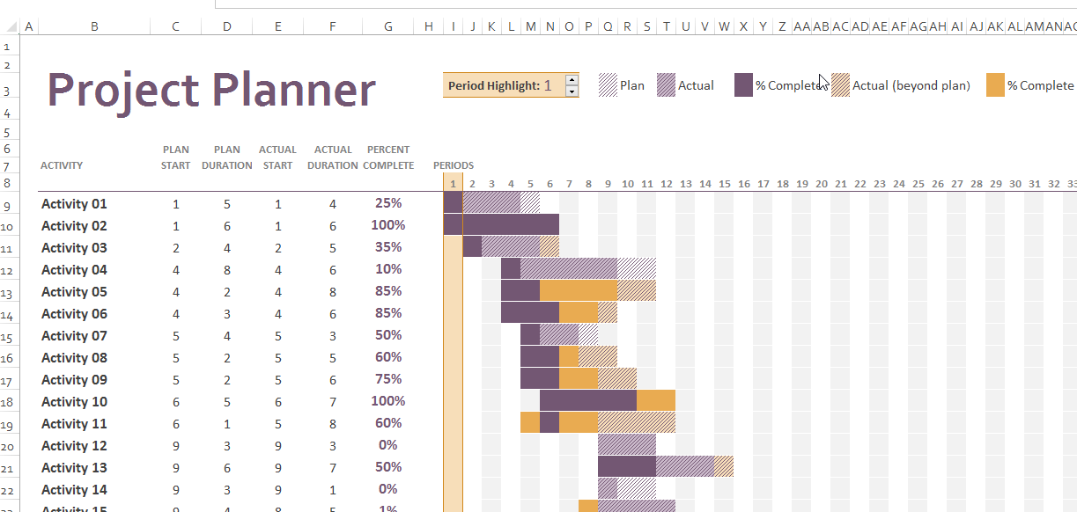
Use Microsoft Excel – Gantt Project Planner to help you create the Gantt Chart.
Each feature/function, sub feature/function should be structured and recorded as a monitored task in the project Gantt chart. The progress of each task should be updated and checked against plan. Plan it over the timeframe from Week 4 till Week 17. Use Appendix A (Page 11) as a guide for your timeline. For each task, the resource (i.e. name of student) should be attached too.

